CHECK OUT PROCEDURE

Thank you for your kind cooperation

The apartment must be delivered in good order and conditions.

The refrigerator must be completely empty (please throw away any products in the refrigerator)

The dishes, silverware and kitchen utensils must be washed, dried and returned to their proper place.

GARBAGE: Please remember to take it out EVERY day to prevent bad odors
Garbage must be removed from the apt. and placed outside before checking out

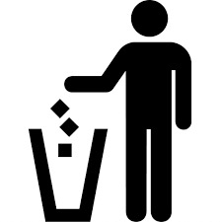On the left of the elevator you will find the “shut”

Bed linen and towels should be placed in a pile for an easier inventory count.

Used bars of soap, toothbrushes and personal care items must be disposed before checking out.

The remaining chores are to be performed by the housekeeper.

Have a wonderful time at home!

********************************************************

PROCEDIMIENTO PARA EL CHECK OUT

Agradecemos su colaboración

El departamento debe entregarse básicamente limpio y ordenado.

La nevera (heladera) vacía en su totalidad

Los platos y utensilios de cocina limpios, secos y guardados.

Basura: por favor saque la basura todos los días para prevenir malos olores.

Por favor no deje basura en el apt. después del check out.

A la izquierda del ascensor se encuentra el “shut”

Las sabanas y toallas apiladas para facilitar el conteo en el check out.

Los jabones utilizados, cepillos de dientes y todo lo de uso personal del baño debe tirarse antes de la entregar el departamento.

Les deseamos una maravillosa estadía!!

